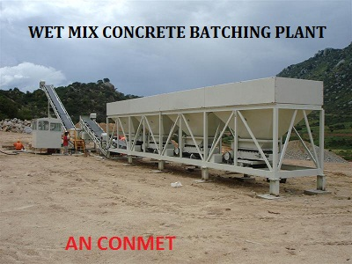
WET MIX CONCRETE BATCHING PLANT
AN CONMET wet mix plants are manufactured with best of the components and accessories. The unique design features makes it most efficient in terms of operational costs, and ensures close control of the quality of output. Available in fixed or variable speed drives, the plant is well equipped with adjustable gates at its bins. The design of twin shaft pug mill ensures fast, continuous & homogenous mixing of aggregates & additives. Besides, the surge hopper arrangement allows discharge into trucks without shutdown & spillage.
Salient Features
• | Available in 120/160/200/250/300/350 TPH Capacity.
• | Modern Wet Mix Technology.
• | Designed For Domestic / International Market.
• | Modular Design For Containerized Transport.
• | Portable or Stationery.
• | Easy To Operate.
• | Highly Accurate Aggregate Feeders.
• | Fully Automatic Computerised Control Panel Board.
• | Electronic Weighment System with Load Cell.
• | An Electronic Water Flow Meter with Sensor Unit.
• | A Monoblock Water Pump.

Optionals
• | Vibrating Screen 1.1M³
• | Water Tank 10,000 / 15,000 Lit capacity
• | C.T.A.B System
• | Storage Silo with Load out Conveyor
• | Printout System

Technical Specification
PARAMETERS | UNIT | MWMP 120 | MWMP 160 | MWMP 200 | MWMP 250
Output Capacity | TPH | 120 | 160 | 200 | 250
Four Been Feeder
Capacity | M³ | 30 | 36 | 36 | 45
Loading Width | Mt. | 3.21 | 3.7 | 3.7 | 3.7
Auxiliary Conveyor | mm/hp | 500/2 | 500/3 | 500/3 | 500/3
Main Conveyor | mm/hp | 600/5 | 600/5 | 600/5 | 750/7.5
Vibrator for fine Agg. Bin | hp | 1 | 1 | 1 | 1
Connected Load | hp | 14.5 | 20.5 | 20.5 | 20.5
Charging Conveyor | mm/hp | 600/7.5 | 600/7.5 | 600/7.5 | 750/10
Pug Mill (Mixer)
Capacity | M³ | 1.66 | 2 | 2.75 | 2.75
No. of Arms Pair | Pair | 14 (28) | 18 (36) | 22 (44) | 22 (44)
Connected Load | hp | 25 | 30 | 40 | 50
Water Pump | hp | 3 | 3 | 3 | 3
Hydraulic Power Pack | hp | 5 | 5 | 5 | 5
Gob Hopper Without Load out Conveyor | Ton | 1* | 1* | 1* | 1*
Gob Hopper With Load out Conveyor | Ton | 1* | 1* | 1* | 1*
Load out Belt Conveyor | mm | 600 | 600 | 600 | 750
Connected Load | hp | 5 | 5 | 5 | 7.5
Storage Silo | MT | 25* | 25 | 25 | 25
Load out Conveyor | mm | 600 | 800 | 800 | 800
Connected Load | hp | 7.5 | 15 | 15 | 15
Total Connected Load | hp | 57.5 | 84 | 95 | 106.5

Optional Accessories
PARAMETERS | UNIT | MWMP 120 | MWMP 160 | MWMP 200 | MWMP 250
Vibrating Screen
Screening Area | M³ | 1.1 | 1.1 | 1.1 | 1.1
Connected Load | hp | 3 | 3 | 3 | 3
Water Tank | Ltr. | 10,000 | 15,000 | 15,000 | 15,000

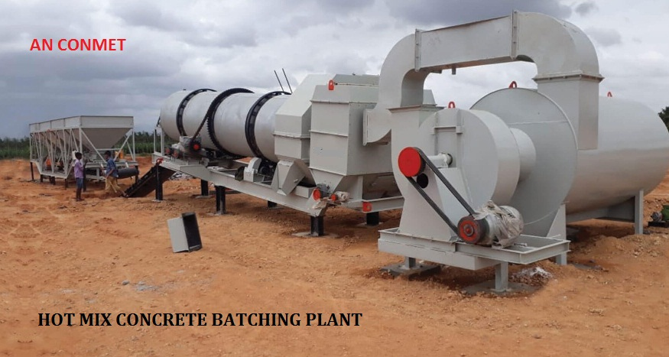
HOT MIX CONCRETE BATCHING PLANT
We manufacture an conmet mixing plants – drum type in capacities 40 tph to 120 tph. Capacities above 120 tph are available on request. Our plants are designed for those contractors who are looking for a reliable machine which can serve them for years to come.
These plants are ideal for road contractors who want to make high volumes of hot mix asphalt without compromising on the quality factor. Stationary mix plant means that the customer will station the plant at one place and forget it. The plant by an conmet will then endlessly serve the customer with high volumes. Many of our existing customers do road work and sometimes prefer to sell the hot mix. The control panel’s ability to store large number of mix recipes make the job easier for the asphalt plant operator. The control panel is with user friendly software making the operation smooth.
An conmet series of drum mix plant is now more modern, complete and efficient to satisfy your needs. We always strive to make key changes in our equipment to make it more and more suitable as per your needs. Our aim is to give intelligent and efficient solutions to customers which aid in the profitability of the customer.

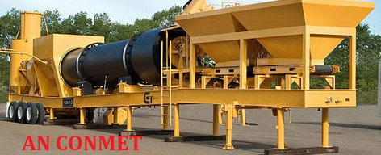

MOBILE HOT MIX PLANT

AN CONMET Mixer is extremely compact and entirely self-contained plants, trailer mounted on 4 nos. pneumatic wheels with drawbar and turntable to ensure easy towing. All controls are within easy reach of the operator.
Easy accessibility to all parts and lubricating points for regular and quick maintenance has been given utmost importance in design. All materials used are of correct and specified grades and are properly tested.

- FEEDER
A bucket elevator is provided to discharge aggregate into the drying cylinder through the feeding ring

- MODEL & TYEP
‘AN CONMET ’ Bitumen Mixer, Model ACS-10, capacity 6-10 TPH,
- Drying Cylinder
Drying Cylinder discharges heated aggregate into the storage ring. It is supported on two roller tracks running on nos. guide rollers driven by chain and sprocket wheel. Lifting flights are wear resistant and replaceable.
- Aggregate Burner
Fitted to the discharge end of the drying cylinder, with a fuel pump for feeding fuel and air blower for supplying air.
- Air Blower
Driven by the engine through a v-belt and is of suitable capacity for the burners provided.
- Storage Ring
The discharge end of the drying cylinder is provided with a storage ring fitted with lifting buckets which discharge the hot aggregate into the batching chute.
- Batching Chute
The batching chute has a fixed volume. Hot aggregate is discharged from chute to paddle mixer by a lever which opens the radial door for discharging the aggregate into the paddle mixer and simultaneously closes a deflector plate at the top of the chute to prevent any material being discharged into the chute while the radial door is open. A thermometer is supplied to register the temperature of the stones in the chute.
- Drum Hoist
A wire rope hoist is provided with lifting frame for easy and convenient loading of bitumen from barrels n to the boiler.
- Bitumen Supply System
An integral bitumen boiler and bitumen pump is provided for feeding bitumen into the calibrated bitumen bucket for discharge into the pug mill. The quantity of bitumen can be metered through a 3-way cock.
- Mixer
The aggregate and bitumen are mixed in a paddle mixer, fitted with two paddle shafts mounted with arms and tips which rotate in opposite directions. The shafts are gear driven and mounted on lubricated bearings. The paddle tips are replaceable and coated with special hard facing alloy to give them longer life in operation. This arrangement provides positive mixing and gives a homogenous mix, which is discharged through a door at the bottom operated by a lever.
- Chimney
Chimney for drawing out the hot gases is provided which can be folded during transportation.
- Chassis
The whole unit is mounted on a strong chassis of welded and bolted construction with rolled and folded steel sections and provided with four pneumatic tyres. Four strong mechanical parking jacks are fitted.
- Optional
Insulated bitumen boiler, overrun and parking brakes, load out conveyor for hot mix material.

Technical Specification
Model | Bitumen Mixer Model ACS-10
Length | 7100 mm.
Width | 2008 mm.
Height with chimney | 5250 mm.
Height with chimney folded | 2850 mm.
Drier drum diameter (outer) | 700 mm.
Drier drum length | 2008 mm.
Batching chute capacity | 300 kg.
Pug mill capacity | 350 kg.
Bitumen boiler capacity | 750 ltrs.
Fuel tank capacity (Burner) | 175 ltrs.
Fuel tank capacity (Engine) | 40 ltrs.
Bitumen bucket capacity | 40 ltrs.
Aggregate size usable | Up to 30 mm.

