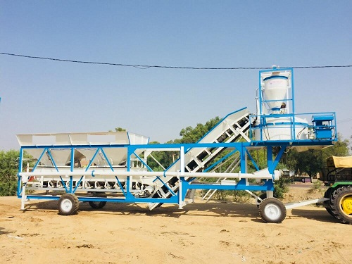
MOBILE BATCHINH PLANT
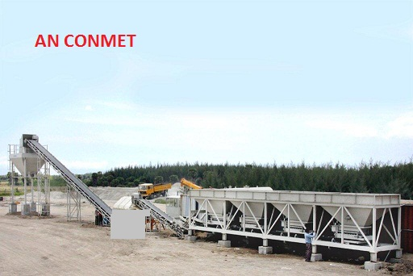
WET MIX CONCRETE BATCHING PLANT
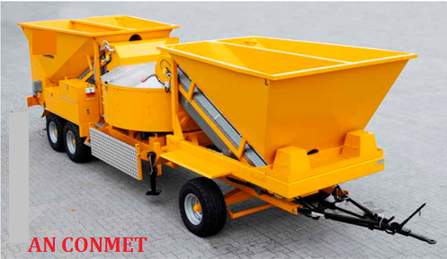
MOBILE BATCHING PLANT
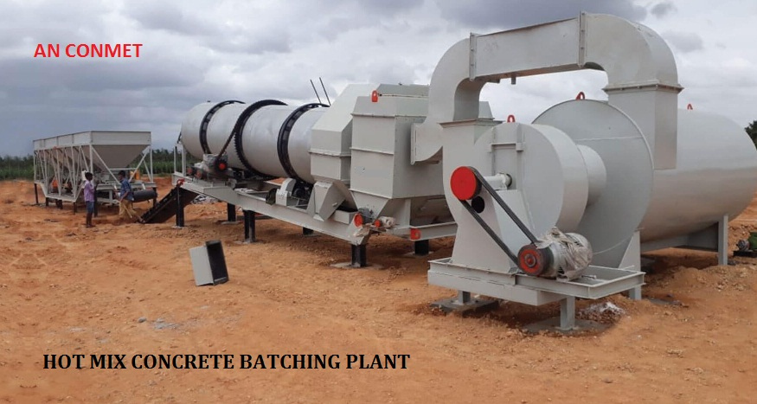
HOT MIX CONCRETE BATCHING
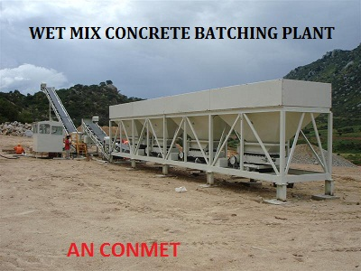
WET MIX CONCRETE BATCHING PLANT
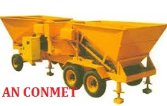
MOBILE CONCRETE BATCHING PLANT
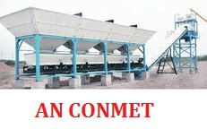
WET MIX CONCRETE BATCHING PLANT

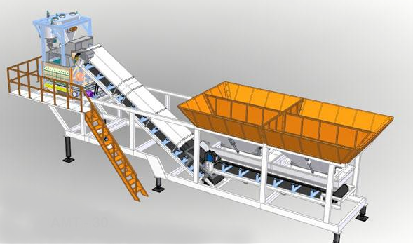
CONCRETE BATCHING PLANT 2/4 BIN
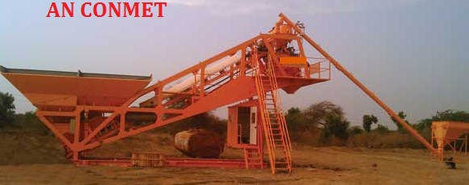
2/4 BIN CONCRETE MBATCHINH PLANT
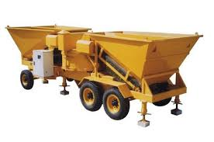
MOBILE CONCRETE BATCHING PLANT

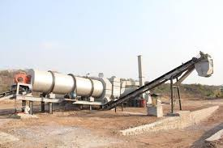
HOT MIX PLANT

